Software Architecture Report

Name: Lea Stanisavljevic

Class: ACS61
Contents
Name: Lea Stanisavljevic 1
Class: ACS61 1
1. Use Case Diagram 2
2. Program Walkthrough 2
2.1. List and Explain the Software used for this Project: 2

Use Case Diagram
A use case diagram is a type of Unified Modelling Language (UML) diagram used to graphically show the interactions between users (known as actors) and a system. It describes the several ways users may use the system, so enabling stakeholders to grasp from the user's point of view the functionality of the system.
Early phases of software development benefit especially from use case diagrams since they:
- Show who will use the system eg. administratively, customer, etc
- Clearly explain what the users are able to accomplish eg.log in, place an order, etc
- Help designers and developers grasp the needs they must fulfil.
They comprise actors, use cases and relationships. By emphasising user interactions, these diagrams help to guarantee that the final product satisfies consumer expectations and needs.

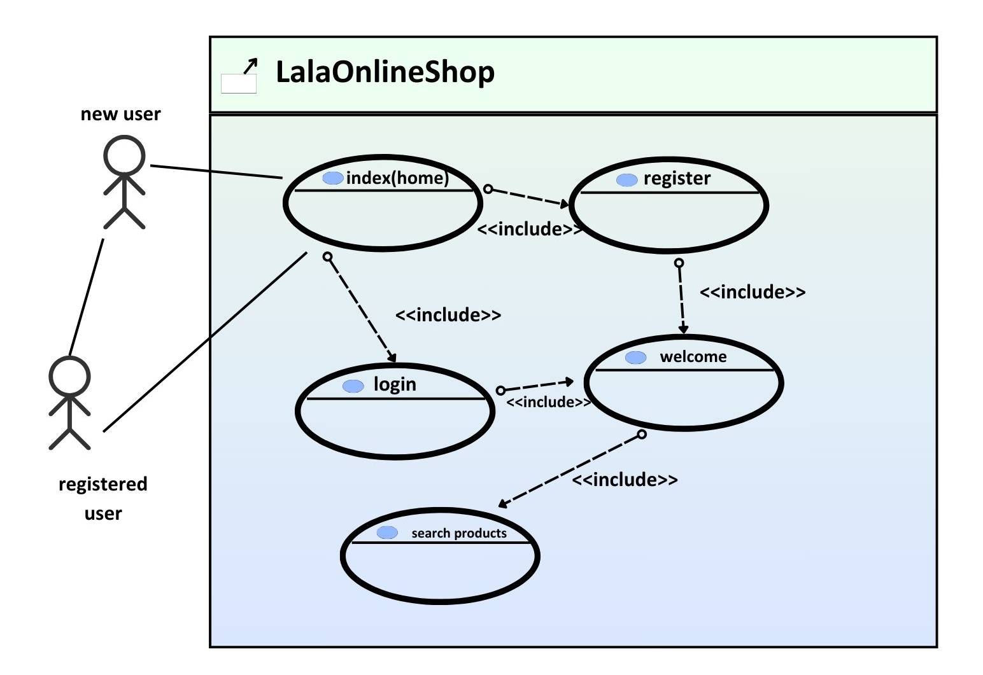

2. Program Walkthrough

2.1. List and Explain the Software used for this Project:

• Eclipse IDE for Java EE Developers
Designed for web application development. Eclipse offers tools for effective coding, compiling, debugging and distributing Java EE apps.

• Apache Tomcat Server
A lightweight and widely-used web server and servlet container used to host the Java-based web application.

• Database in MySQL
A relational database management system available for storing and controlling the data of the application open-source.

• HTML, CSS, JavaScript
Front-end languages for application user interface creation.

2.2 List and explain the java servlets used on your site:

1. CreateDatabase.java
Purpose: Creates the main MySQL database.
Functionality:
- Connects to MySQL.
- Creates a database called Lala_IRL if it doesn't exist.

2. CreateProductsTable.java
Purpose: Creates the table for storing product information.
Functionality:
- Connects to the Lala_IRL database.
- Creates a products table with fields like id, productname, brand, price, qty, and img.

3. CreateRegTable.java
Purpose: Creates the table for storing user registration data.
Functionality:
- Connects to the database.
- Creates a userTable with fields like userName, userPass, userEmail, and userPostalRegion.

4. InsertData.java
Purpose: Inserts default product data into the products table.
Functionality:
- Executes multiple SQL INSERT statements to populate the products table with predefined cosmetics items.

5. RegistrationServlet.java
Purpose: Handles user registration.
Functionality:
- Accepts user inputs (name, pass, email, PostalRegion).
- Inserts them into the userTable.

6. LoginServlet.java
Purpose: Handles user login.
Functionality:
- Validates user credentials using LoginDatabaseConnector.
- Redirects to a welcome page if successful, otherwise shows an error message.

7. LoginDatabaseConnector.java
Purpose: Helper class for user login validation.
Functionality:
- Connects to the database.
- Checks if username and password match a record in userTable.

8. EshopDisplayServlet.java
Purpose: Displays available product categories/brands.
Functionality:
- Retrieves distinct brands from the products table.
- Includes HTML pages and displays login success messages if applicable.

9. QueryServlet.java
Purpose: Displays products of a selected type.
Functionality:
Retrieves and displays products based on producttype from the database
Generates an HTML table with product information and quantity controls.

10. OrderServlet.java
Purpose: Handles product ordering and checkout.
Functionality:
- Updates quantities in the products table based on user selection.
- Displays a checkout summary with total price and order confirmation message.

11. SearchServlet.java
Purpose: Handles product search functionality.
Functionality:
- Receives a search query from the user
- Matches the query with product names in the products table (with specific hardcoded matches for better accuracy).
- Displays matching product(s) or a message if no match is found.
- Provides a button to view the product using QueryServlet.

12. WelcomeServlet.java
Purpose: Welcomes users after successful login and loads the shop interface.
Functionality:
- Displays a personalized welcome message with the user's name.
- Includes the EshopDisplayServlet to display available brands or categories.

2.3 List the web pages on your site:
index.html – This is the home page of the site. It provides a welcome message, background audio, and navigation buttons for login and registration.
login.html – This is the login page where existing users can enter their credentials to access the store.
registration.html – This is the user registration page where new users can sign up by providing personal and contact details.
welcome.html – This page is shown after successful registration, welcoming the user and providing links to either return to the homepage or go to the shop.
ShopFront.html – This is the main storefront page. It displays products, includes a search bar, and links to more details or purchase options.

2.4- Steps taken to purchase something on website:
- When the website is first loaded, the index.html page appears. The user is greeted with a welcome message and presented with two main options: Login or Register. Here, the user can register a new user or login as a previous user.
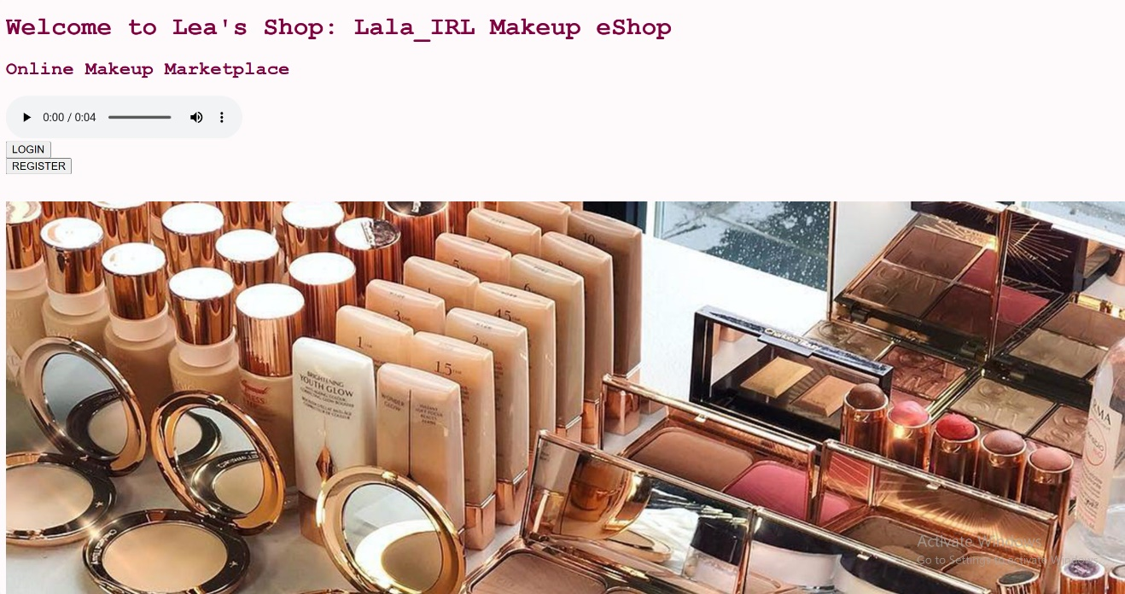

- By clicking on the Register button, the user is directed to registration.html.
This page contains the following input fields:
- Full Name
- Password
- Confirm Password
- Email
- Confirm Email
- Postal Region (County selection)
- Account Registration Submission
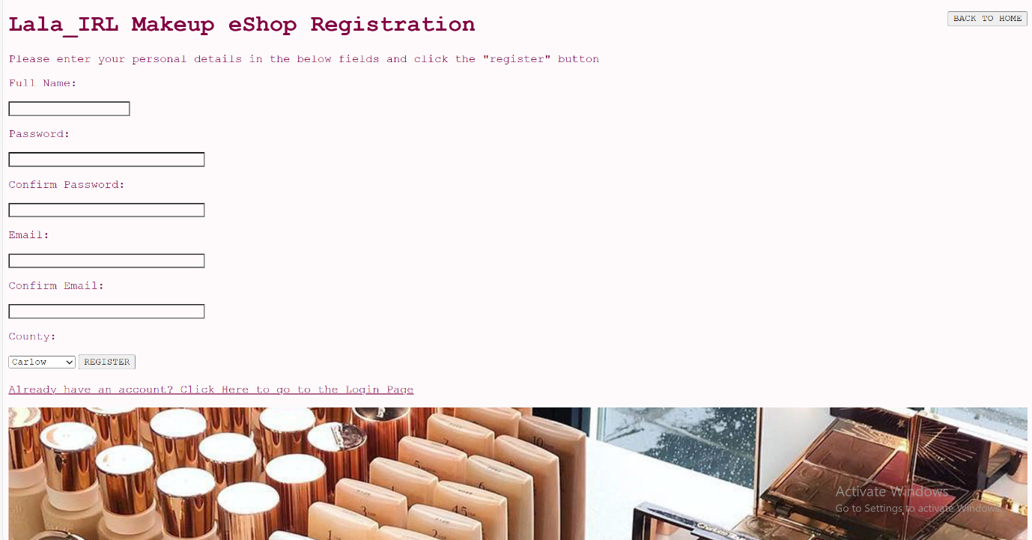
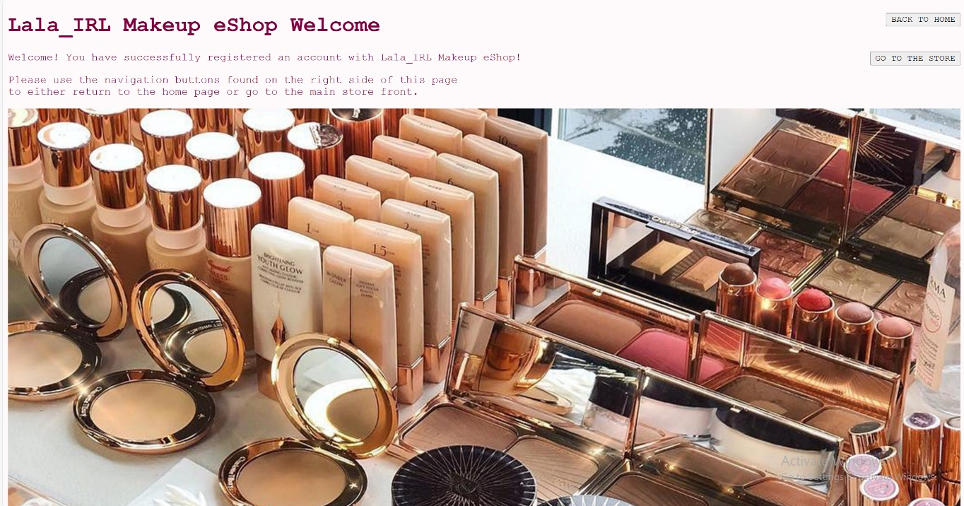
- Once the user completes the registration form and submits it, the data is sent to RegistrationServlet. After successful registration, the user is shown the welcome.html page, confirming the account creation and prompting the user to visit the store.
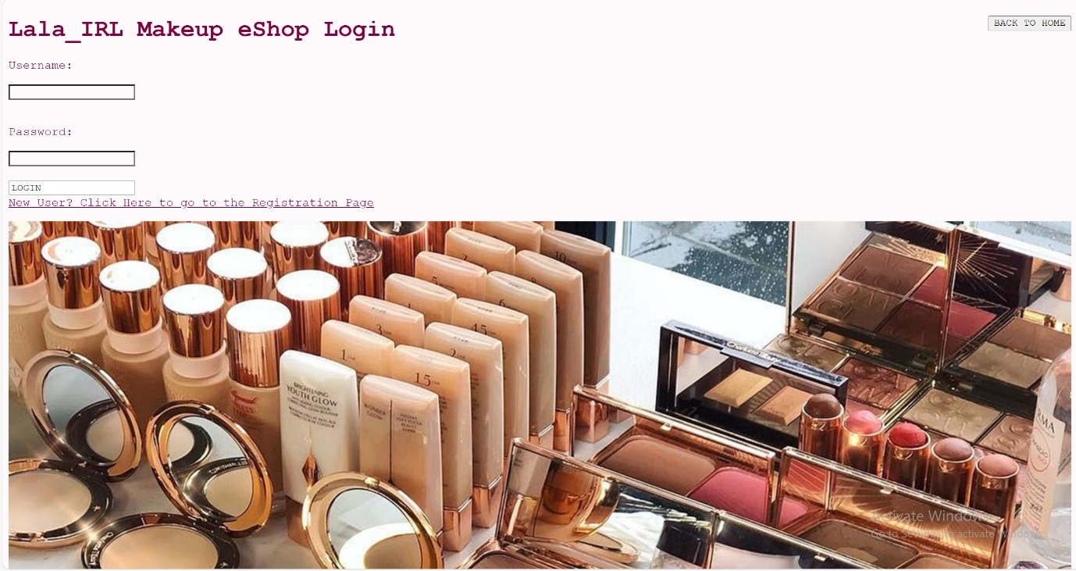
- The user then navigates to login.html, where they enter their username and password. These credentials are verified by LoginServlet and LoginDatabaseConnector.

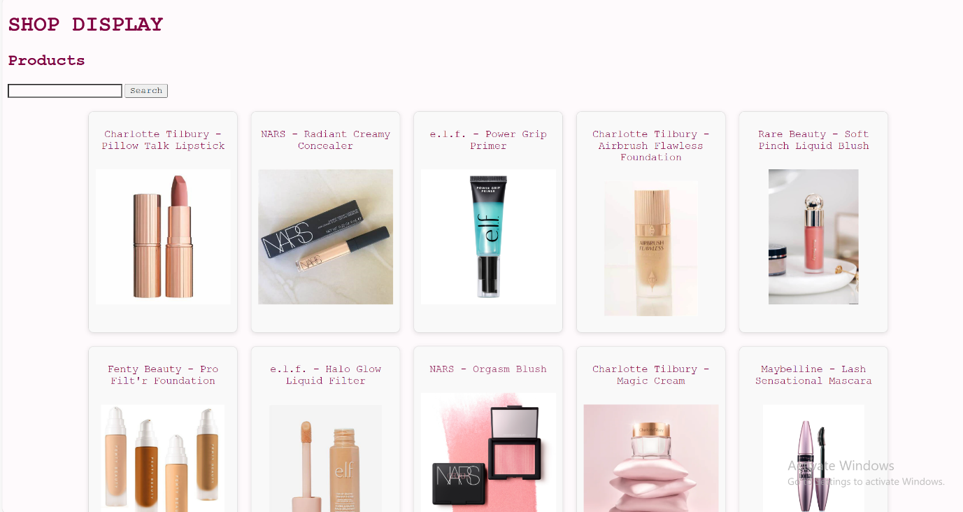
- Upon successful login, the user is redirected to WelcomeServlet, which displays a personalized welcome message. The EshopDisplayServlet is also loaded here, showing the available product brands/categories.

- Clicking on a brand or selecting a product type (e.g., "foundation", "lipstick") sends the user to QueryServlet, which displays all relevant products in stock. Each product has a checkbox, image, price, and quantity selector (with +/- buttons).

- After selecting desired products and quantities, the user clicks the Order button. The selection is processed by OrderServlet, which:
- Updates stock quantities in the database
- Offers a button to return to the homepage

3.Feasiblity Study

Commercial Feasibility
The Lala_IRL Makeup eShop addresses a growing online demand for cosmetic products, especially among younger demographics who prefer digital shopping experiences. The platform differentiates itself by:
- Offering popular, trend-driven products (e.g., Charlotte Tilbury, Fenty Beauty)
- Providing a curated and stylish shopping experience
- Featuring a smooth registration, login, and ordering process through servlet-based interactions
Market trends in the beauty industry show increasing online engagement and the shop is well-positioned to target both casual and dedicated makeup buyers in the digital space.

Financial Feasibility
This project was developed as a proof-of-concept and that’s why there’s minimal financial risk. In a real-world application, the financial considerations would include:
- Startup Costs: Website domain, hosting, database infrastructure and branding
- Operational Costs: Inventory management, packaging, shipping and customer support
- Revenue Model: Product sales with a potential for affiliate partnerships or advertising
Given the low-cost technical stack (HTML, CSS, Java Servlets, MySQL) and open-source tools, the project remains financially feasible for small-scale or pilot deployment. Return on investment (ROI) is promising with proper marketing and SEO integration.

Organizational Feasibility
Chosen Methodology: Agile (Scrum)
Agile was selected for its iterative nature, allowing flexibility during development and room for continuous improvement based on testing and feedback.

Project Roles:
Product Owner: Defines the features (e.g., shop flow, search function)
Scrum Master: Facilitates team coordination and removes blockers
Developers: Create the frontend (HTML/CSS) and backend (Java servlets, MySQL)

Testers: Perform functionality and usability testing
Designer: Responsible for UI/UX styling and assets

Project Stages:
- Planning & Requirement Gathering
- Define features (login, register, search, order)
- Choose tools (Java, MySQL, Tomcat)

- Design
- Create wireframes for HTML pages
- Define database schema (products, userTable)

- Development
- Set up database and implement servlets (e.g., RegistrationServlet, QueryServlet)
- Build HTML/CSS front-end

- Testing
- Functional testing of all forms and data handling
- Test data validation, error handling, and order flow

- Deployment
- Package the application into a .war file
- Deploy to Tomcat and test in a live environment

- Evaluation
- User feedback and review
- Adjustments or improvements for scalability

4.Test Bed
Page/Servlet Tested | Expected Result | Actual Result | Change Made
CreateProductsTable | A table for storing products will be created in the database | 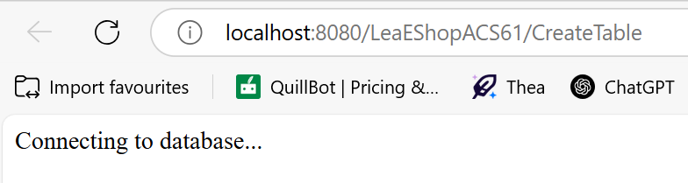 | Checked that the correct database name was used in the servlet code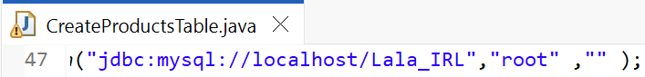
RegistrationServlet | New user data is inserted into the userTable in the database after form submission | User was not added, no error shown | Verified field names in form matched servlet parameters; added e.printStackTrace() to catch block
SearchServlet | Products matching search term are displayed dynamically from the database | Page doesn’t load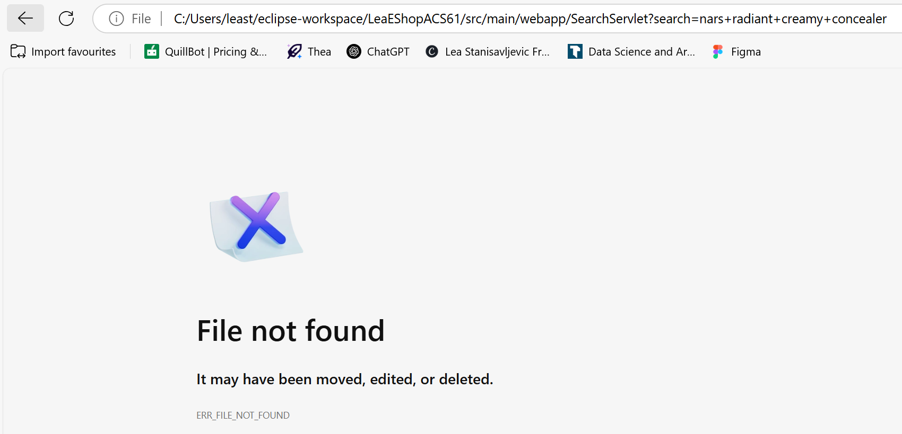 | Changed SQL query to use LIKE properly and made search case-insensitive, added error logging to debug but still not working
LoginServlet | Valid user logs in and is redirected to WelcomeServlet | Login works | No changes made
QueryServlet | Products filtered by selected category are displayed in a dynamic table | Only static HTML displays, no product table is shown | Fixed SQL query to include proper brand value from request but still didn’t work.

5. Review of Design

5.1. Does the Web Database App work?
The database and static pages work correctly and the user can:
- Access the homepage (index.html)
- Navigate to registration and login pages
- Register new accounts and log in successfully (confirmed if database operations are traced)
However, the dynamic features that rely on servlet-database interaction like the product search and ordering do not function as expected at runtime. Pages like ShopFront.html display static content correctly, but database-driven functionality (e.g., SearchServlet, QueryServlet, OrderServlet) does not return results or perform updates properly.

5.2. If not, what problems did you have?
The key issue is that the servlets are not displaying or processing dynamic product data correctly, even though the database connection itself is set up and contains product records.
Search and product display return empty or no results, even though the database contains matching entries.
The servlet output never reaches the user, likely due to one or more of these:
- SQL errors being silently caught (catch (Exception e) { })
- Improper query formatting (e.g., string matching not working due to lowercase/uppercase or extra spaces)
- Servlet not included or redirected correctly (e.g., missing or incorrect RequestDispatcher logic)

5.3. What did you find difficult or tricky with the project?
Mixing HTML inside Java servlets made the code harder to debug and maintain.
Troubleshooting servlet failures was difficult because many try-catch blocks suppressed errors instead of printing them.
Search functionality was tricky due to:
- Hardcoded matches in SearchServlet which didn’t match actual database values
- Lack of real-time feedback when search fails
- Updating quantities dynamically in InsertData.java Servlet was challenging and complex due to multiple product selections

5.4. What could be done to make the Web Database App better?
- Fix servlet error handling and add e.printStackTrace(); inside all catch blocks to see what’s going wrong
- Use equalsIgnoreCase() or LIKE properly in SQL to avoid mismatches in search
- Use JSP or templating instead of writing raw HTML in Java code
- Add meaningful feedback for errors (e.g., "Product not found", "Something went wrong with your order")
- Improve servlet-to-HTML logic with clearer separation of concerns
- Use a debugger or logs to trace what the servlet is doing (e.g., logging SQL output)
- Deploy on Tomcat locally and test servlet URLs manually, confirming each step works (e.g., /SearchServlet?search=lipstick)

